THE TOWER OF BABEL
Genesis 11:3-9

MAIN POINT: God loves people, and He wants us to listen to Him and obey Him because He knows what is best.

KEY VERSE: “But then I will purify what all of the nations say. And they will use their words to worship Me. They will serve Me together.” Zephaniah 3:9

Craft Ideas

“Tower of Babel” Craft Picture

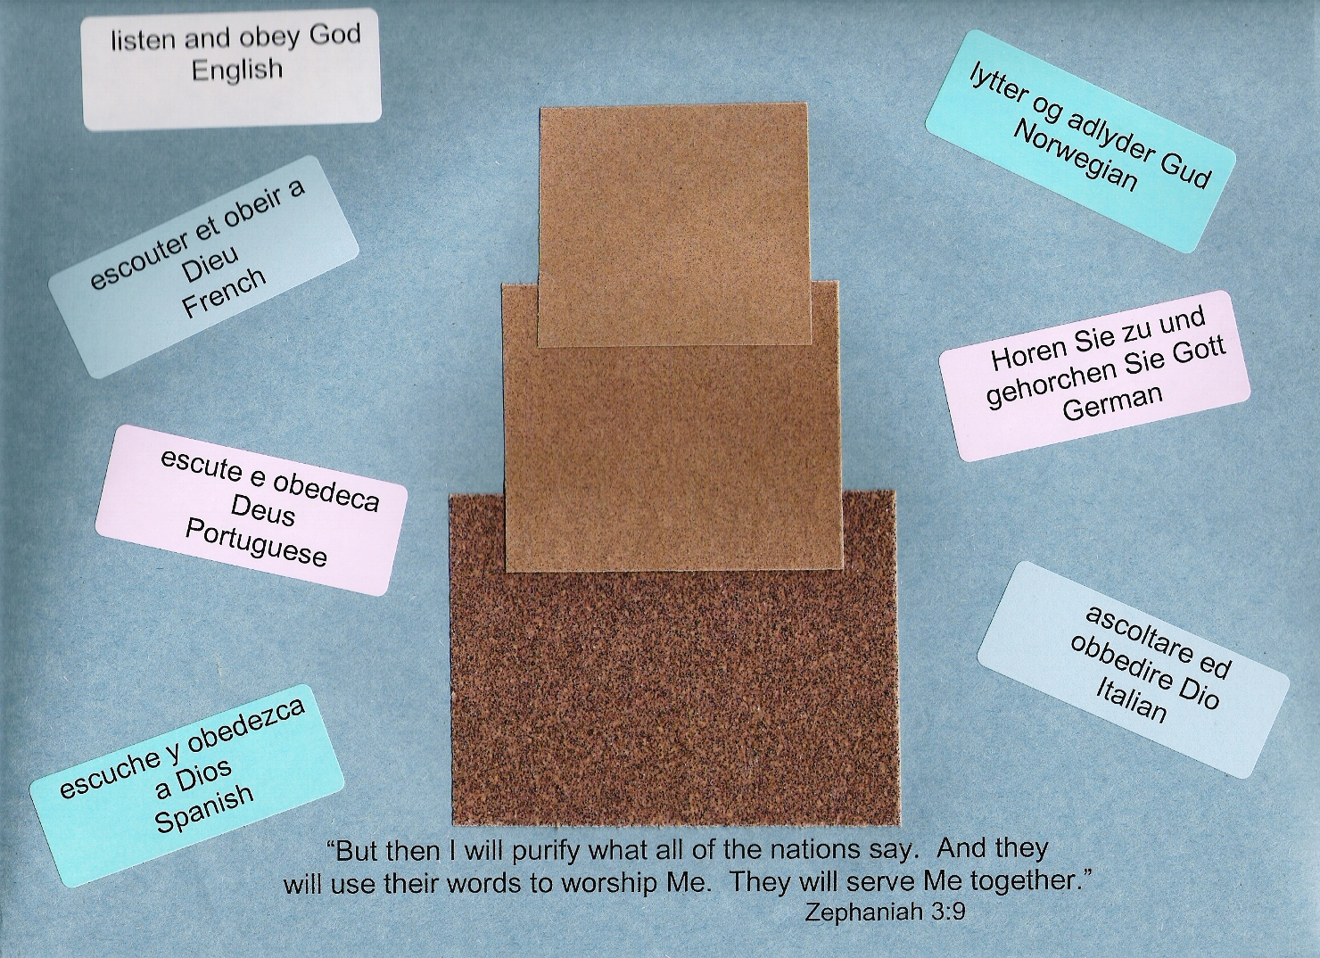

Craft Supplies: colored cardstock, sandpaper, address labels in several colors

- Print “Zephaniah 3:9” on landscape print option.
- Load cardstock paper into bypass tray of copier and make needed copies.
- Print “listen and obey God” onto address labels.
- Print the following languages onto address labels:
escouter et obeir a Dieu French
escute e obedeca Deus Portuguese
escuche y obedezca a Dios Spanish
lytter og adlyder Gud Norwegian
Horen Sie zu und gehorchen Sie Gott German
ascoltare ed obbedire Dio Italian
- Cut 3 squares of sandpaper or brown paper for “tower”. Stack and glue to cardstock.
- Apply language stickers around tower on Tower of Babel picture.

Optional craft: “Trust in the Lord” magnet, www.orientaltrading.com, 48/2957

